Name: _______________________________ Date: _____________

Yeast Bread Web-Quest

**Purpose:** This web-quest is designed to review principles of yeast bread preparation, and introduce you to yeast bread preparation methods. It will also introduce you to career paths associated with the baking unit.

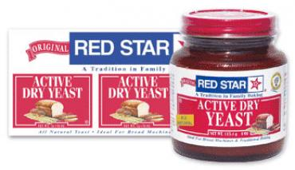**Yeast Breads**

There are two companies that produce most of the yeast that we purchase in grocery stores: Fleischmann’s and Red Star Yeast. We will be using the websites provided by both of these companies and other sites on the Internet to explore the history of yeast breads and yeast bread preparation in this web-quest.

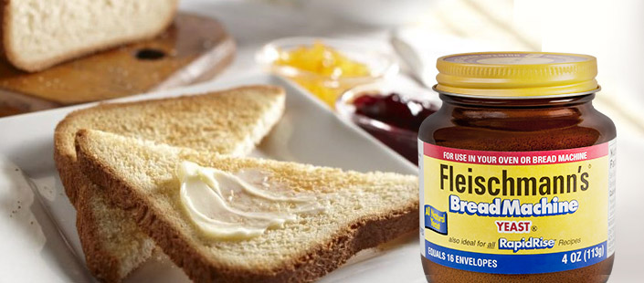**Instructions:**

Click on the links provided throughout this document to answer the questions that follow.

***History of Yeast Bread Making***

1. Use the information provided by Red Star Yeast at <http://redstaryeast.com/science-yeast/story-yeast/> to answer the following questions:
   1. How long has yeast been used to make bread?

_____________________________________________________________

* 1. How were breads leavened in ancient (Bible) times?

_____________________________________________________________

_____________________________________________________________

_____________________________________________________________

* 1. When was yeast first identified as a living organism?

_____________________________________________________________

1. Use the information provided on [Fleischmann’s Website](http://www.breadworld.com/history) to answer the following questions about the history of their product:
   1. Where was the first commercial yeast made in the United States?

_____________________________________________________________

* 1. Where did the Fleischmann brothers have a concession named *The Vienna Bakery*, a concession where they introduced their commercial yeast to the world?

_____________________________________________________________

* 1. What type of yeast did the Fleischmann brothers display at their concession in 1876?

_____________________________________________________________

* 1. Why does this website say that active dry yeast was invented?

_____________________________________________________________

* 1. How much faster does this company claim that rapid rise yeast is in baking than active dry yeast?

_____________________________________________________________

_____________________________________________________________

***Yeast Bread Basics***

1. What is the main [function or purpose](http://www.breadworld.com/education/History-of-Yeast) of yeast in baked goods?

_____________________________________________________________

_____________________________________________________________

_____________________________________________________________

1. What are **three things** that[Louis Pasteur discovered](http://www.breadworld.com/education/History-of-Yeast) about how yeast works?
   1. _____________________________________________________________
   2. _____________________________________________________________

* 1. _____________________________________________________________

1. **Name and describe the** **three** roles that the yeast fungus, Saccharomyces cerevisiae, fulfills in baking, according to [Red Star Yeast](http://redstaryeast.com/yeast-baking-lessons/yeast-types-usage/):
   1. _____________________________________________________________

* 1. _____________________________________________________________

* 1. _____________________________________________________________

1. We have reviewed the roles of many ingredients in the production of baked goods throughout the Quick Bread Unit. Please summarize the information provided on Fleischmann’s page regarding the roles that the following ingredients play:
   1. Eggs:

_____________________________________________________________

* 1. Fat:

_____________________________________________________________

1. Yeast breads are made from yeast that comes from various sources.

Complete the chart provided below using the links provided on the name of the product:

|  |  |  |  |
| --- | --- | --- | --- |
| **Product Name/Type** | **Description** | **Special Considerations when Using this Yeast** | **Baked Product Examples**  **(You can search on the Internet for examples)** |
| [Cake Yeast](http://redstaryeast.com/yeast-baking-lessons/yeast-types-usage/cake-fresh-yeast/) |  |  |  |
| [Active Dry Yeast](http://redstaryeast.com/products/red-star/red-star-active-dry-yeast/) |  |  |  |
| [Instant Yeast](http://redstaryeast.com/yeast-baking-lessons/yeast-types-usage/instant-or-fast-rising-yeast/) (also known as [Rapidrise](http://www.breadworld.com/education/Yeast-Basics) Yeast) |  |  |  |
| [Starter](http://www.bhg.com/recipes/how-to/bake/how-to-make-yeast-bread/) |  |  |  |

1. How can yeast be [activated or proofed](http://www.breadworld.com/education/Yeast-Basics)?

_____________________________________________________________

_____________________________________________________________

1. At which [temperature(s) will yeast be killed](http://www.breadworld.com/education/Yeast-Basics)?

_____________________________________________________________

_____________________________________________________________

1. How long will [activated yeast dough last in the refrigerator](http://www.breadworld.com/education/Yeast-Basics) if you need to stop in the middle of making it for some reason?

_____________________________________________________________

1. Where should [dough be placed to rise](http://www.breadworld.com/education/Yeast-Basics) (or proof)?

_____________________________________________________________

1. How [long will packaged yeast last](http://redstaryeast.com/yeast-baking-lessons/yeast-shelf-life-storage/dry-yeast/)?

_____________________________________________________________

